PRACTICAL-1

Assume JK Enterprises organization wants to start with new application development. There are four members in a group. Application will have two modules to develop. For better workflow, they have decided to use IBM Security Identity Manager (ISIM) for handling organization activity. Organization has decided to use IBM Security Directory Server (SDS) feature to create two server instances for workflow and wants to test working of newly created instances.

**IAM**

* Identity and access management (IAM) in enterprise IT is about defining and managing the roles and access privileges of individual network users and the circumstances in which users are granted (or denied) those privileges. Those users might be customers (customer identity management) or employees (employee identity management. The core objective of IAM systems is one digital identity per individual. Once that digital identity has been established, it must be maintained, modified and monitored throughout each user’s “access lifecycle.”
* Thus, the overarching goal of identity management is to “grant access to the right enterprise assets to the right users in the right context, from a user’s system onboarding to permission authorizations to the offboarding of that user as needed in a timely fashion,” according to Yassir Abousselham, senior vice president and chief security officer for Okta, an enterprise identity and access management provider.
* IAM systems provide administrators with the tools and technologies to change a user’s role, track user activities, create reports on those activities, and enforce policies on an ongoing basis. These systems are designed to provide a means of administering user access across an entire enterprise and to ensure compliance with corporate policies and government regulations.

**Major functionality in scenario:**

1. Server instance creation
2. Start and Stop of server instance

**STEPS:**

1. Listing server instance in SDS

**/opt/ibm/ldap/V6.4/sbin/idsilist –a**

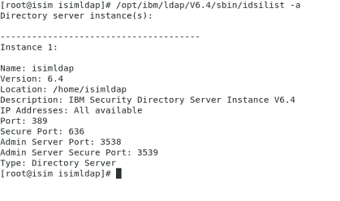

1. Navigating to SDS folder

**cd /opt/ibm/ldap/V6.4/sbin/**



1. Adding new Server instance

**./idsadduser –u idsldap1 –w P@ssw0rd –l /home/idsldap3 –g idsldap –n**

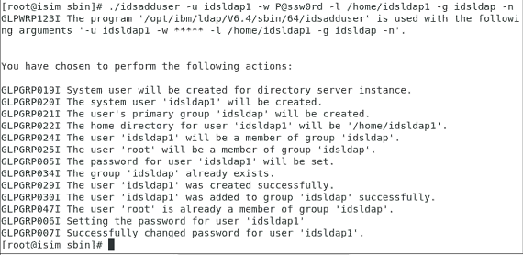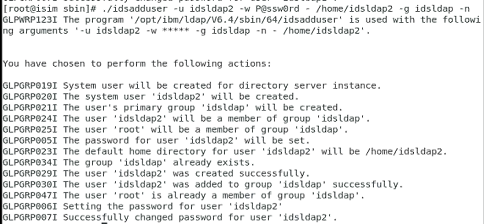

1. Creating server instance

**./idsicrt –I idsldap1 –e encryptionseed –l /home/idsldap1 –n**

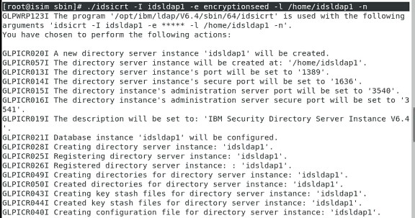

**./idsicrt –I idsldap1 –e encryptionseed –l /home/idsldap1 –n**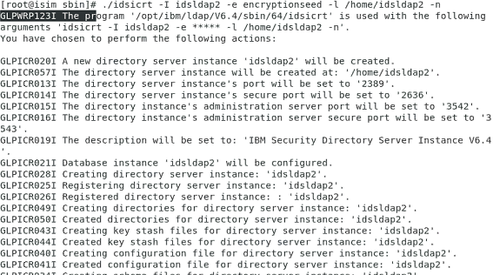

1. Creating DB2 database for instance

**./idscfgdb –I idsldap1 –w P@ssw0rd –a idsldap –t idsldap1 –l /home/idsldap1 –n**

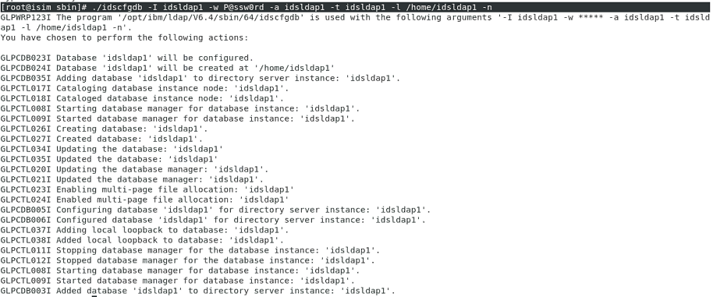**./idscfgdb –I idsldap2 –w P@ssw0rd –a idsldap –t idsldap2 –l /home/idsldap2 –n**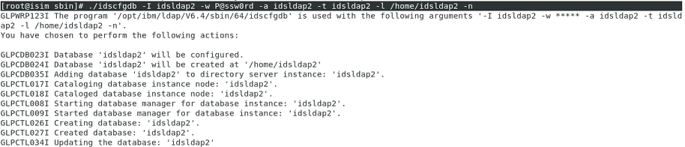

1. Creating admin user

**/idsdnpw –I idsldap1 –u cn=root –p P@ssw0rd –n**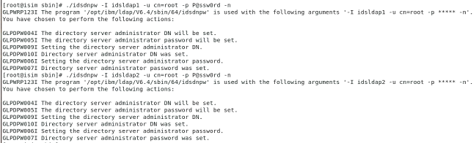

1. Start server instance

**/opt/ibm/ldap/V6.4/sbin/ibmslapd –I idsldap1 –n –t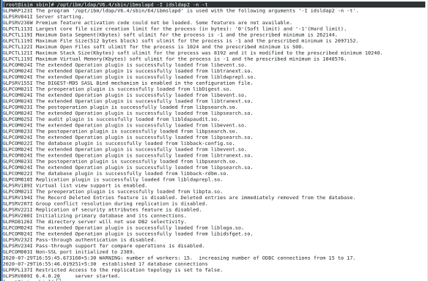/opt/ibm/ldap/V6.4/sbin/ibmslapd –I idsldap2 –n –t**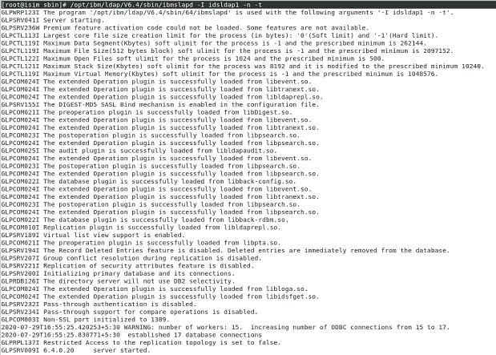

Open Firefox then choose Web Admin Tool from bookmarks

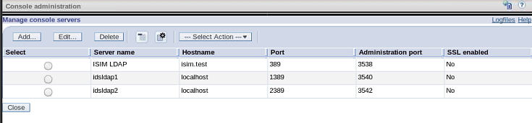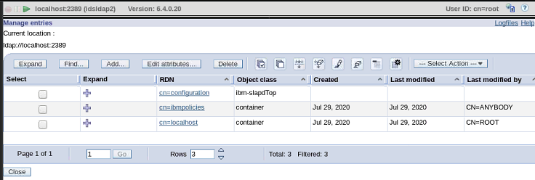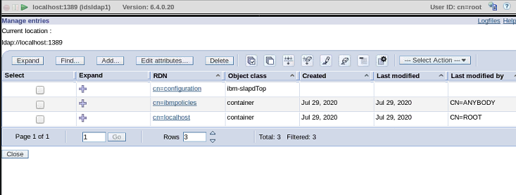

1. Stop server instance

**/opt/ibm/ldap/V6.4/sbin/ibmslapd –I idsldap1 –k**

**/opt/ibm/ldap/V6.4/sbin/ibmslapd –I idsldap2 –k**

1. Listing Server instance

**/opt/ibm/ldap/V6.4/sbin/idsilist –a**

